
IIE ROSEBANK COLLEGE

Student Name | Tihanca Leeu
Student Number | ST10519525
Module Name | Web Development
Module Code | WEDE5020
Lecturer | Rhulani Kobeni
Programme | Diploma In IT In Software Development

StoryVerse Website – POE Part 2

Table of Contents
Live Github link 3
Sitemap/Pages List 4
Changelog – Feedback from Part 1 Fixed for Part 2 5
Screenshots to insert 6
Features Implemented 9
Reference List 10

Live Github link

https://tihanca2005-debug.github.io/StoryVerse-WebsitePart2/

Sitemap/Pages List
- index.html - Home page with banner, navigation and footer
- about.html – About StoryVerse
- products.html -Product listing for books and movies using responsive CSS Grid
- enquiry.html – Enquiry form for customers to ask about books
- contact.html – Contact details, map and form with JavaScript validation

Changelog – Feedback from Part 1 Fixed for Part 2

Date | Feedback from Part 1 | What I Fixed in Part 2
10 May | Products staked vertical | Added display: grid; grid-template-columns: repeat(3, 1fr);
10 May | Not responsive on phone | Added @media(max-width: 768px) and @media(max-width: 480px)
10 May | No hover effects | Added a:hover and .product-card:hover
10 May | Only had 3 product images in part 1, needed more variety | Added more book and movie photos – increased from 3 to 8 product images for both movies and books in images folder and updated products.html
10 May | Old product images were low quality/ not consistent | Changed all product photos – replaced Part 1 images with new high-quality, same-size book covers for consistent look

Screenshots to insert

Figure 1 : Home page desktop
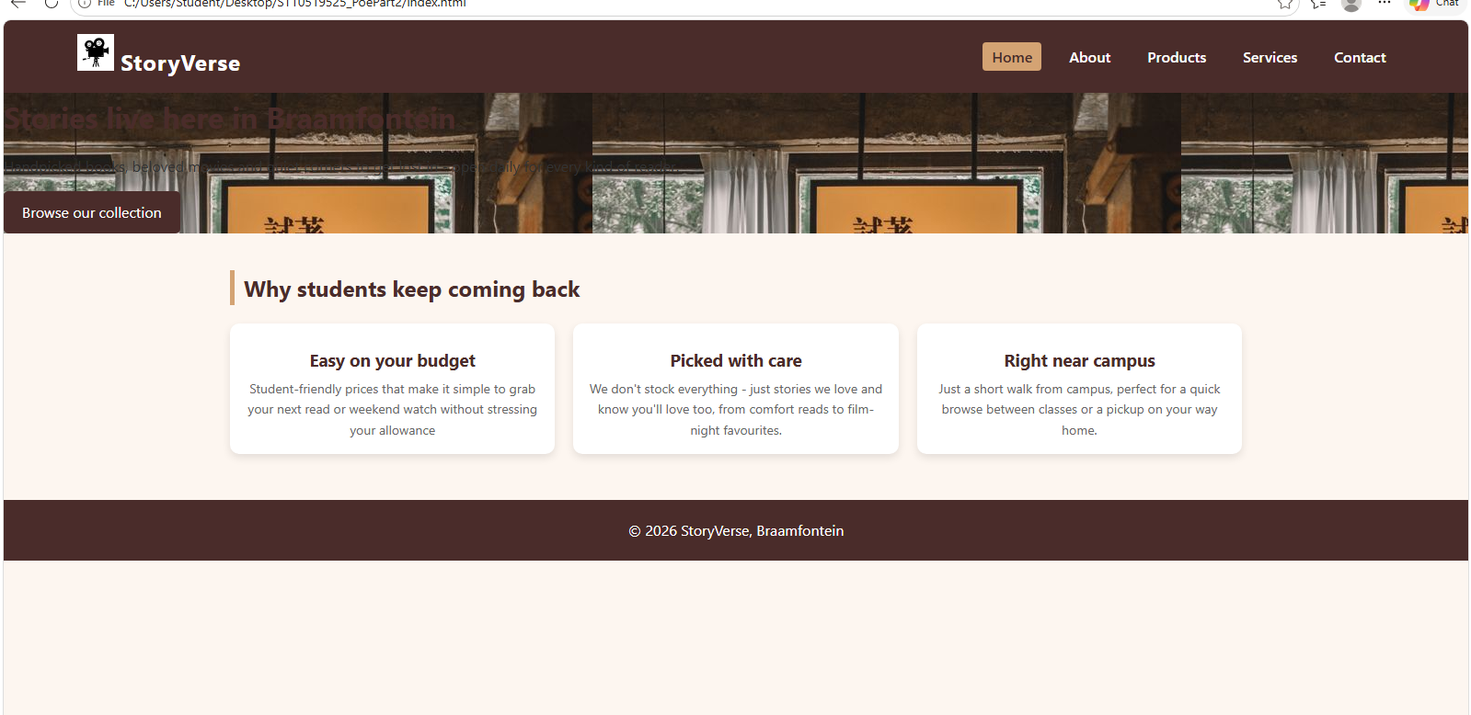

Figure 2 : Products page showing rows – proves grid
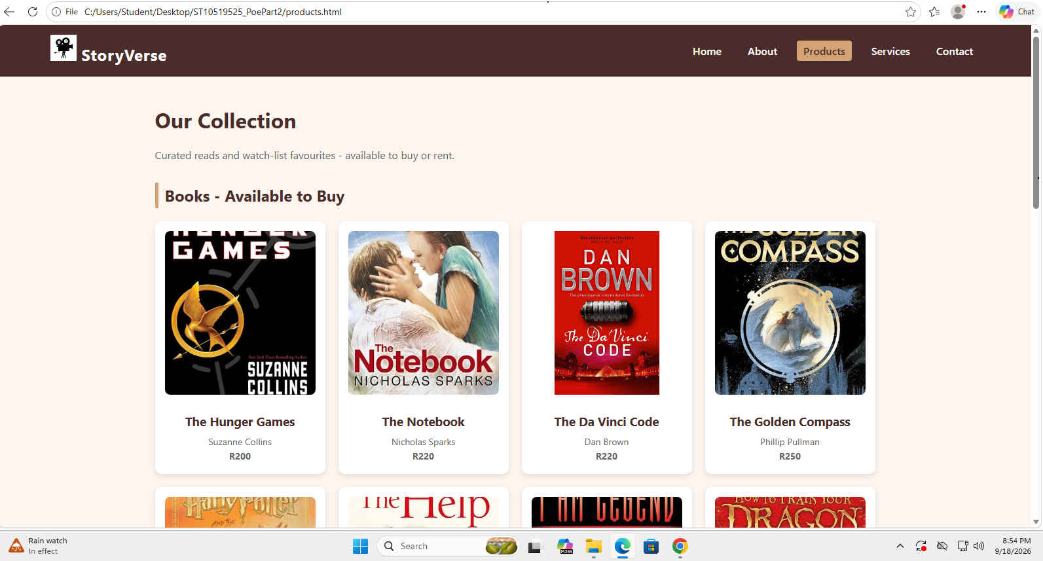

Figure 3 : Mobile View
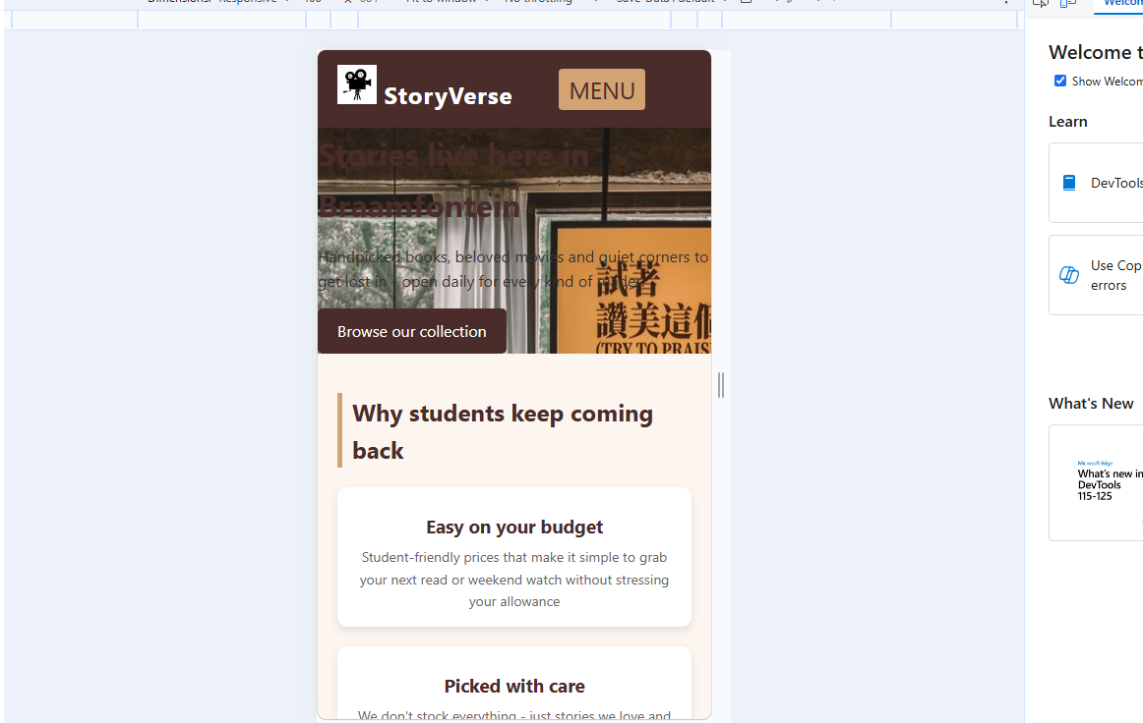

Figure 4 : GitHub – commits
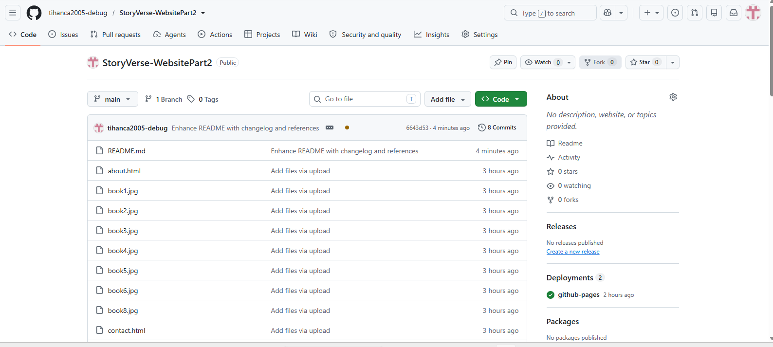

Figure 5 : GitHub Pages live link
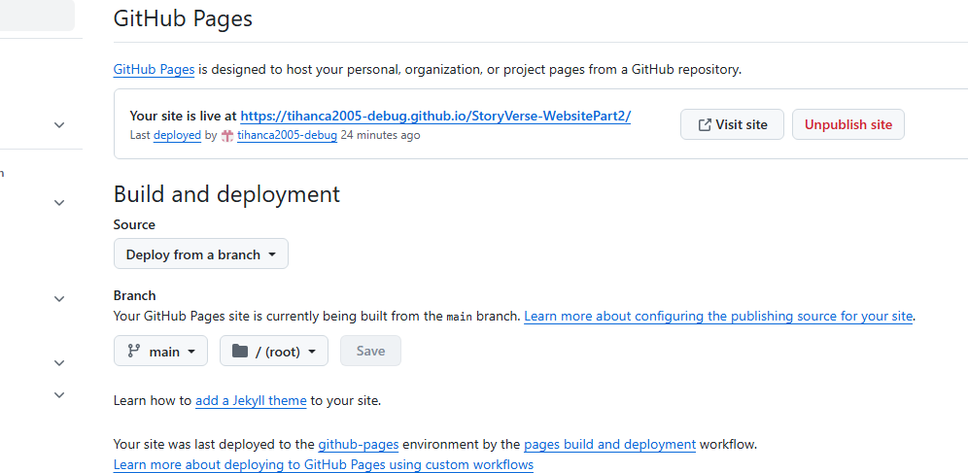

Figure 6 : Form validation

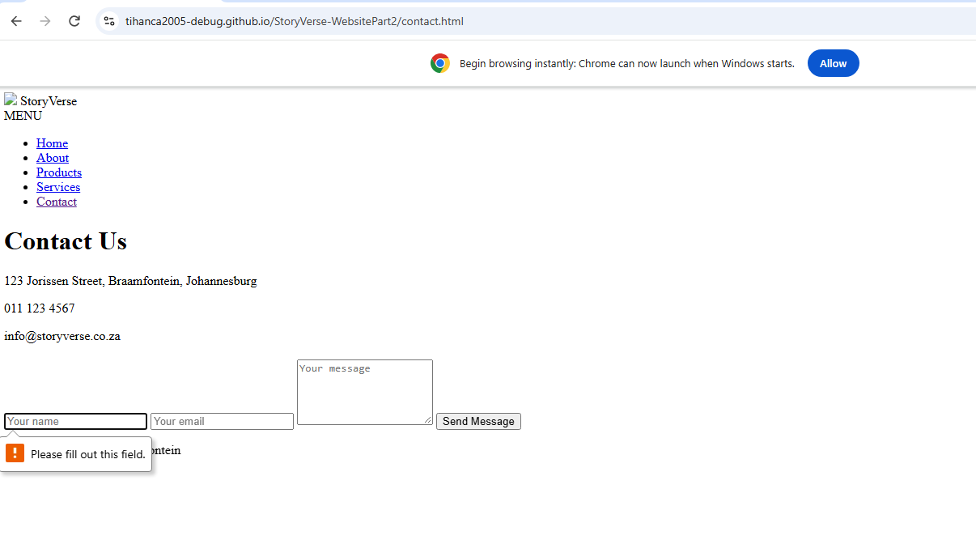

Features Implemented
- External CSS used for all styling
- CSS Grid for product layout
- Media Queries for responsive design
- Hamburger menu with JavaScript toggleMenu() function
- JavaScript form validation for email and required fields
- Pseudo-classes :hover and :focus

Reference List

Mozilla Developer Network, 2025. _Responsive Web Design Basics_. Available at: https://developer.mozilla.org/en-US/docs/Learn/CSS/CSS_layout/Responsive_Design (Accessed: 15 September 2026).

W3Schools, 2025. _CSS Grid Layout_. Available at: https://www.w3schools.com/css/css_grid.asp (Accessed: 15 September 2026).

W3Schools, 2025. _HTML Forms_. Available at: https://www.w3schools.com/html/html_forms.asp (Accessed: 15 September 2026).

